Screenshot 1

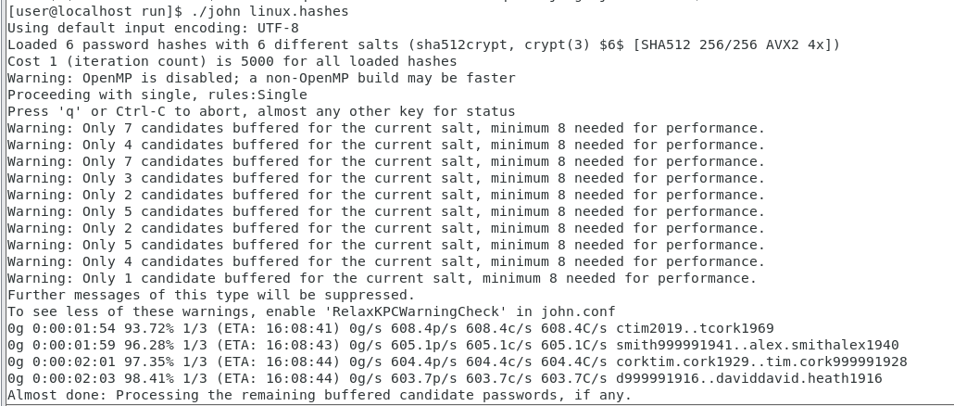

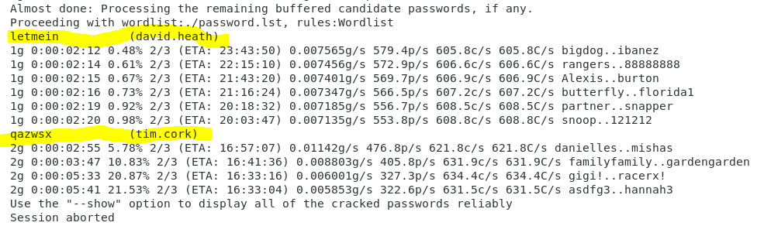

Screenshot 2

Screenshot 3

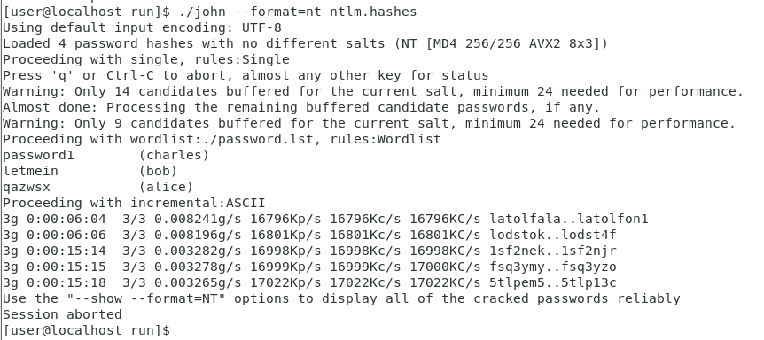

I think it didn’t recover the same four user passwords because this NTLM (nt) style hash has a higher security level. Therefore, the administrator user does not show up potentially due to higher authorization needs. The previous LM style password hash has lower security and reveals the passwords in all uppercase and up to a maximum of seven characters. If the characters are longer than 7 characters, it is split up. I can use hints from the NT cracked passwords to figure out what the missing password is. In the previous screenshot, the LM or NT style reveals the password being split up into two. The first part of the password is “PASSWOR” and the second part under Administrator:2 is “D1234”. This hint reveals that the missing password under the NTLM (nt) style hash is password1234 for administrator.